

SCHOOL OF COMPUTING
SEMESTER 1/20252026

SECP1513 – TECHNOLOGY & INFORMATION SYSTEM
SECTION 01
PROJECT – Digital Solutions For ADHD & Autism Community
Lecturer: PM Dr Azurah bte A. Samah
Name | Matric ID
Norjuma Nazwa binti Jamaluddin | A25CS0299
Nurcarmelia Aiesya binti Mohamad Sani | A25CS0326
Nur Irdina Amira binti Muhammad Rozee | A25CS0317
Lok Jie Ying | A24SC5023
https://drive.google.com/file/d/1PJk70yTzn0bBefO1gaAzQsTOSaTVjTdW/view?usp=sharing
Table of Contents
Content | Page
Introduction | 3
Empathy | 3
Define | 4
Ideate | 4
Prototyping | 5
Test | 6
Conclusion | 6
Reflection | 7 - 10
Lampiran A | 11 - 15
References | 16

Introduction
Attention Deficit Hyperactive Disorder (ADHD) is a neurodevelopmental condition commonly associated with hyperactivity, impulsivity and difficulties in emottional regulation. For parents and caregivers to recognizing early sign of overstimulation or hypercactive episodes can be quite challenging, especially when these changes happen gradually without clear warning signs. This lack of early awareness can lead to stressful situations and emotional escalation for both parents or caregiver and the patient. Therefore, we design our “Caresense” to help them.

Empathy
Individuals with ADHD often experience sudden cognitive or emotional overstimulation during daily activities such as studying, attending classes or using digital devices for a long time. During these moments, their body may show physical responses including excessive sweating, increased heart rate or feelings of restlessness. However, many individuals find it difficult to understand whether these reactions are caused by ADHD-related overstimulation or by normal factors such as physical movement or hot weather.

Due to this uncertainty, ADHD-related overstimulation is often ignored or noticed too late, after the individual has already frustration, loss of focus, or emotional exhaustion. Many individuals with ADHD struggle to self-regulate in the moment. Parents of children with ADHD also face challenges in identifying when their child truly needs support, which limiting their ability to provide timely support. Therefore, this highlights a need for a supportive system that helps ADHD individuals and their caregivers better understand their physiological changes and respond earlier.

Define
Physical responses such as sweating and increased heart rate are commonly associated with ADHD-related arousal, but these responses can also happen during physical exercise or in hot environments. This overlap makes it difficult for ADHD individuals to differentiate between ADHD-related overstimulation and normal bodily reactions.

As a result, relying on single physiological signals often leads to misinterpretation and false alerts, which may reduce user trust and effectiveness. So, the main challenge is not detecting sweat itself but accurately identifying when these physical responses happen due to ADHD-related cognitive or emotional arousal rather than external conditions.

Therefore, the problem is to design a system that can clearly differentiate ADHD-related overstimulation from physical activities and environmental factors, so that users will receive alerts only when support is truly needed.

Ideate
During the ideate phase of design thinking, our team explored solutions that could support parents or caregivers by providing timely awareness rather than medical diagnosis. We proposed a wearable device that could connected to mobile application that monitors physiological and behavioural indicators such as motion, sweat response and skin temperature. These signals are commonly associated with stress and heightened activity levels. The core idea focuses on a real-time alert system that notifies caregivers when abnormal patterns are detected thus allowing early intervention. By priotizing and immediate feedback, the solution aims to reduce caregiver stress and support safer, more responsive care for individuals with ADHD.

Prototyping
During this phase, we developed both the design of our app and the prototype of our sweat-sensing patch. The sweat-sensing patch is structured as a multilayered system, with each layer serving a distinct functional role to enable non-invasive biochemical monitoring. There are six layers for our patch. The outermost layer is adhesive layer which uses medical-grade acrylic or hydrocolloid materials to secure the patch to the skin. We also use microporous polyurethane to keep it breathable and stable. Next is microfluidic layer which will directd sweat towards the sensing region. Then, we have sensor layer which contain screen-printed electrodes modified with nanomaterial. Next, we have the feedback layer that can notify user of spikes in sweat rate. Moving on to the next layer which is electronics layer. This layer is for digital filtering, signal conditioning and calibration. Finally, for the wireless communication layer, we use thin-film antennas. This will enable a real-time transmission of processed data to external devices. Collectively, these layers form a biocompatible patch that capable of continuous monitoring of sweat biomarkers and streaming the data to a smartphone through our app.
As for our app, the features of our app are the bluetooth pairing with the patch. The bluetooth pairing is to secure the connection with our sweat-sensing patch. Next is the real-time data streaming which display live sweat activity. This will show the graph of the sweat activity over time. From the graph, our app also provides information about sweat, motion and temperature of normal people with sweat, motion and temperature of ADHD people. After that, our app also has the alert feature where it will notify the user whenever the biomarker level exceeds the safe ranges. To monitor the session, the user will need to log in so that the data gain can be stored. Lastly, our app has the export and sharing functions. This function allow user to save and share the results to healthcare providers like therapist for further analysis.

Test
The prototype was tested with ADHD users to see if it could help with their needs. Before testing, we gave a demonstration to show what the system does, like how the sweating sensor patch works and how the data is shown on the mobile app. We also explained how the interface works. After that, the users tried out the prototype themselves and explored the app based on the scenarios given. They looked at how the sweat sensor data shows in real time and how notifications appear when certain thresholds are reached. The testing focused on how easy the system is to use, if the information is clear, and if the users feel comfortable using it. The feedback showed that the prototype is easy to understand and helpful for monitoring emotions in ADHD. Some suggestions were made too, like making the interface layout clearer and giving more guidance. Overall, the test helped identify the strengths and weaknesses of the prototype.

Conclusion
In conclusion, the developing of CareSense highlight how design thinking can create a meaningful solution for ADHD individuals and their caregivers like parents. By understanding the problem in a deeper level, our team has concluded the need for a system that can help the caregivers especially parents. CareSense demonstrates both technological innovation and human-centred design. It is also the prove on how technology can be used to help other people if it used wisely. This design thinking project has also create more awareness for people towards the ADHD community.

Reflection:
Norjuma Nazwa binti Jamaluddin：
- What is your goal/dream with regard to your course program?
My goal with this program is to develop skills that allow me to create meaninngful and practical solution that can improve other people's lives. I aim to involved in projects that combine technology,science and design thinking to address everyday issues, especially the one that related to health and well-being. I hope to work in an industry where innovation is not only about technical knowledge but also by understanding user’s needs.
- How does this design thinking impact your goal/dream with regard to your program?
This design thinking project guides me to understand the importance of designing with clear purpose. By working on a device that supports parents or caregivers of ADHD individuals, I learned how to frame problem realistically and ethically. The process strengthens my ability to focus on user’s needs, simplify complex ideas and design solutions from ideas to practical solution.
- What is te action/improvement/plan necessary for you to improve your potential in the industry?
To improve my potential in the industry, I plan to improve my communication skills and gain more experience in project-based learning. I also aim to enhance my knowledge of emerging technologies and user experience design. Furthermore, I desire to improve my teamwork abilities because it’s essential to facilitate good cooperation.

Nur Irdina Amira binti Muhammad Rozee:
- What is your goal/dream with regard to your course program?
My goal is to gain strong knowledge and skills in computer science so that I can work on innovative projects in the technology industry. I want to be able to develop useful applications and solutions that can help people in their daily life.
- How does this design thinking impact your goal/dream with regard to your program?
Design thinking helps me understand the needs of ADHD users from their perspective. It guides me to design simple and user-friendly systems that can help monitor emotions or support focus. This approach helps me achieve my goal of creating useful technology that benefits people with ADHD.
- What is te action/improvement/plan necessary for you to improve your potential in the industry?
To improve my potential, I plan to practice coding regularly, work on real projects, and learn about the latest technologies. I will also improve my communication and teamwork skills to be ready for collaboration in the industry.

Nurcarmelia Aiesya binti Mohamad Sani:
1. What is your goal/dream with regard to your course program?
My goal is to focus fully on my studies and use the knowledge that I gain to help the communities especially in the healthcare field. This is because I believe combination of both technologies and biology can create a significant impact on human health.
2. How does this design thinking impact your goal/dream with regard to your program?
Design thinking teaches me on how to analyse the problem and create the solution for the problem. It also teaches me on how to think in other perspective so that we can understand the problem more. In addition, it made me realise that we need to keep trying until we find the best solution to the problem. These skills are important in my program because we mostly involve in human health, so it is really a valuable experience for me.
3. What is te action/improvement/plan necessary for you to improve your potential in the industry?
To improve my potential especially in industry, I plan to practice solving more problem in real world. This will help me to improve not only my design thinking skills but also my other skills such as analytic thinking skills, coding if the solution required coding and my social skill.

Look Jie Ying：
- What is your goal/dream with regard to your course program?
My goal in this course is to build a strong foundation in computer science so that I can design practical digital solutions in the future. I hope to apply my knowledge to create systems that are not only technically sound but also useful and meaningful for users in real-life situations.
- How does this design thinking impact your goal/dream with regard to your program?
This design thinking project helped me understand the importance of focusing on users’ needs when designing a system. By working on this ADHD-related project, it supports my goal of becoming a developer who can create user-centred solutions that address real problems and improve people’s daily lives.
- What is te action/improvement/plan necessary for you to improve your potential in the industry?
To improve my potential in the industry, I plan to strengthen my technical skills while also improving my communication and teamwork abilities. These skills will help me adapt to real working environments and contribute effectively in the future.

Lampiran A

Work Distribution Table
Content Title | Description | Person in  Charge
Introduction | This part shows the meaning of ADHD. The problem that we choose to solve also stated here and what are the solution that our group choose to solve the problem. | NORJUMA NAZWA
Empathy | This part shows how our group try to understand how ADHD people act and react to things around them. Our team also tried to emphasise with their caregivers like their parents to identify the solution that we can create to help ease their life. It is also to make sure we really understand the problem faced by our user. | LOOK JIE YING
Define | Detailed description of the problem met by our target customer. The solution provided by our app and device. It is explained thoroughly in this part. | LOOK JIE YING
Ideate | This part shows the ideate phase of design thinking. This part also shows how our team explore different kinds of solutions to the problem. Lastly, the best idea for the solutions was selected at the end of our discussion. | NORJUMA NAZWA

Prototyping | This part shows how our patch device can be created and all the materials needed for the creation. In this part, we also explain what the function for each part in our patch device are. Other than that, we also explain on the features of our app, CareSense and the functions of each feature. | NURCARMELIA AIESYA
Test | This part explains how our team do the test and how we demonstrate it to our targeted user. This part also shows how the user tried our prototype and the feedback they gave us after the testing. | NUR IRDINA AMIRA
Conclusion | This part concludes all our process for our design thinking project. It also shows how our solutions can help the ADHD community. | NURCARMELIA AIESYA
Reflection | This part shows all our team members reflection towards this design project thinking. It includes all our goals, the impact of this project personally towards us and what are our resolution to keep up with the industries now. | ALL OF THE MEMBERS

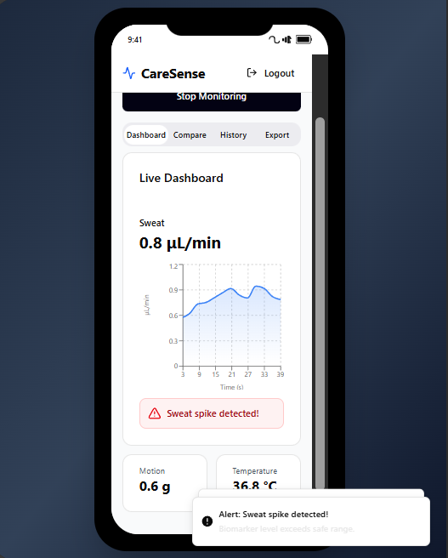
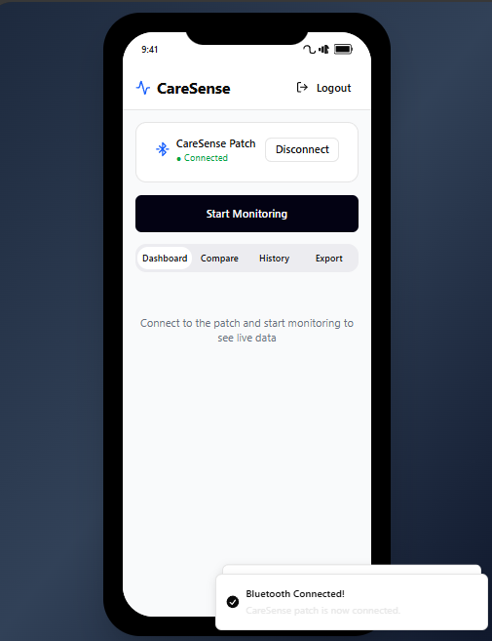
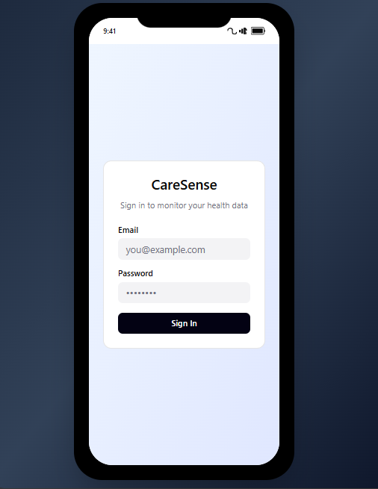
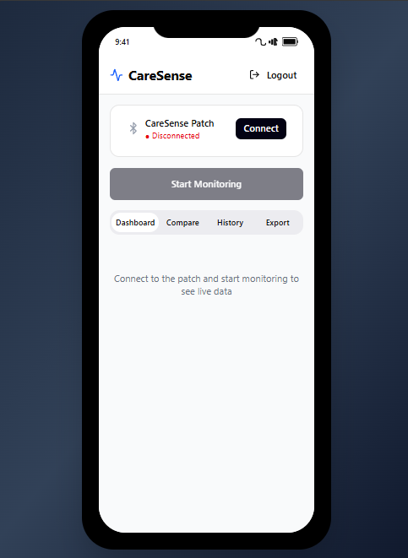
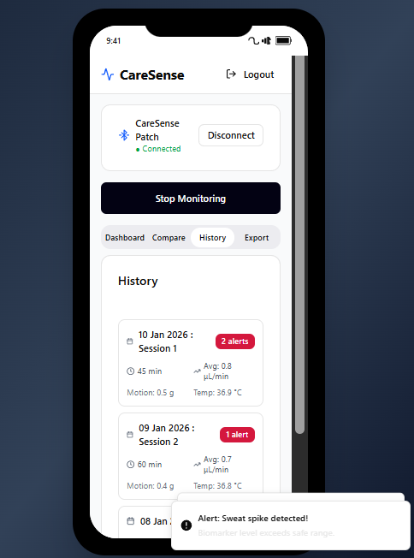
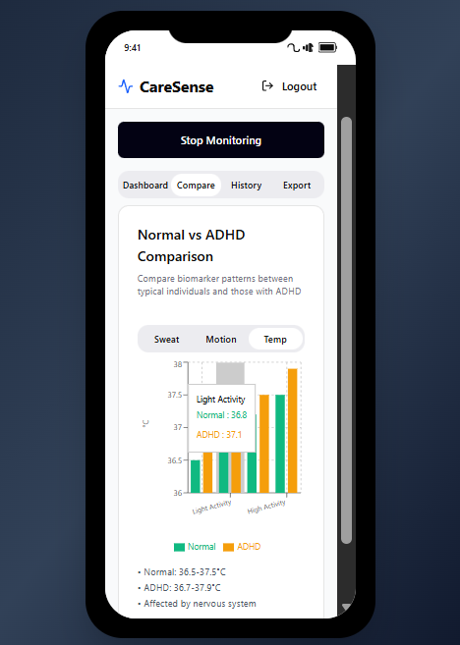
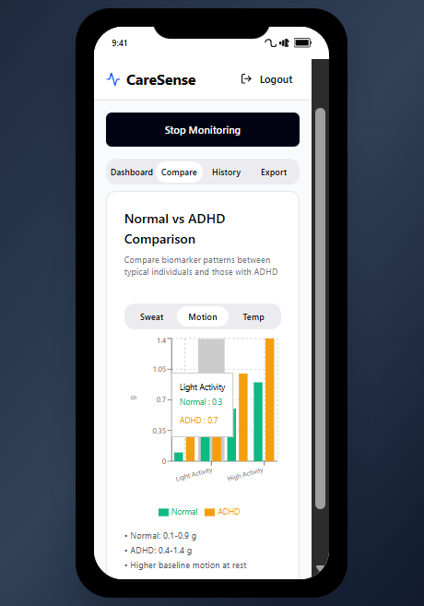
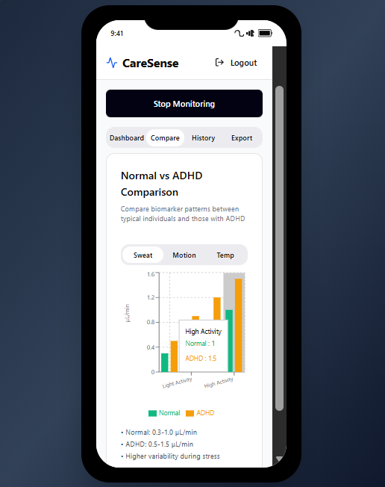

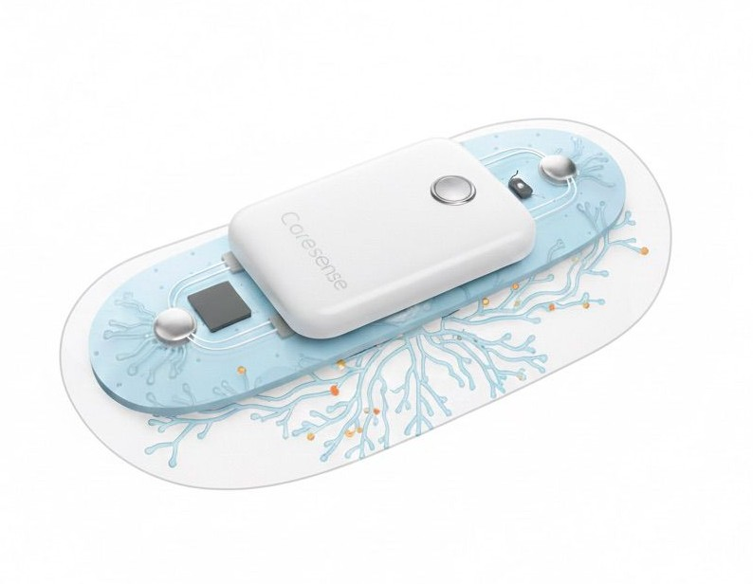
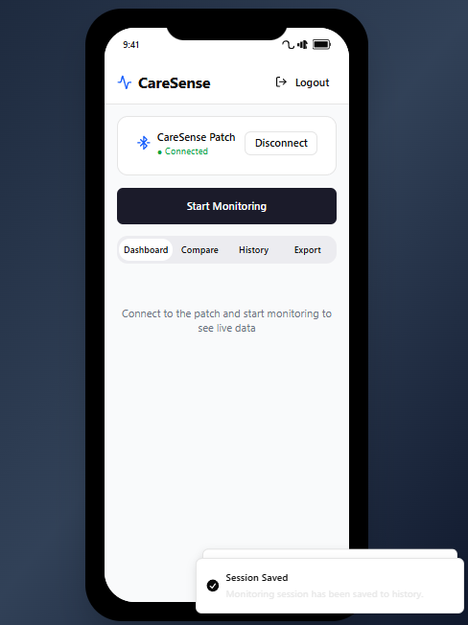
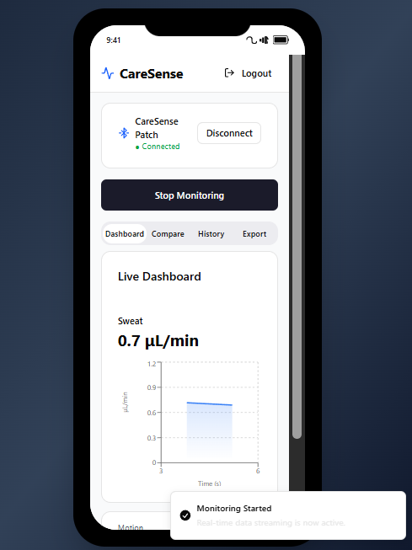
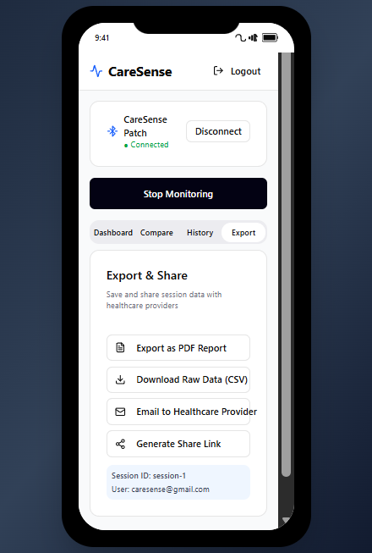

References
- Biology Insights. 2025. “What Is Electrodermal Activity (EDA)?” Biology Insights, July 29, 2025. https://biologyinsights.com/what-is-electrodermal-activity-eda/.
- Shinde, Megha, and Gymama Slaughter. 2025. “Advanced Nanocomposite-Based Electrochemical Sensor for Ultra-Sensitive Dopamine Detection in Physiological Fluids.” Frontiers in Lab-on-a-Chip Technologies 4 (Medical Diagnostics), March 24, 2025. https://doi.org/10.3389/frlct.2025.1549365
- Sun, Yue, Junjie Ma, Yuwei Wang, Sen Qiao, Yihao Feng, Zhanhong Li, Zifeng Wang, Yutong Han, and Zhigang Zhu. 2023. “A Wearable Patch Sensor for Simultaneous Detection of Dopamine and Glucose in Sweat.” Analytica 4 (2): 170–181. https://doi.org/10.3390/analytica4020014

